**Iteration Method**

Dr. M. Mesbahuddin Sarker

IIT,JU

**Iteration Method (Iterative Method)**

**Definition:**

* An **iterative method** is a computational technique that generates a sequence of improving approximate solutions.
* It’s used to **find roots** of equations or **solve systems** of equations.
* An iterative method is **convergent** if the sequence of approximations converges to the actual solution.
* Uses **initial guess** to start.
* **Successive approximations** improve the solution.
* Especially useful for **nonlinear equations** and **large linear systems**.
* Computers are often used due to the **repetitive arithmetic operations**.

**Concept of Iteration:**

* **Iteration** means repeating a process to get closer to a desired result.
* Each repetition = one **iteration**.
* Output of each step becomes the **input** for the next.

**Root Finding Using Iteration:**

Given:  
  **f(x) = 0**

Convert to:  
  **x = φ(x)**

Let:  
  Initial guess **x₀**

Then:  
  **x₁ = φ(x₀)**  
  **x₂ = φ(x₁)**  
  **x₃ = φ(x₂)**  
  ...  
  **xₙ = φ(xₙ₋₁)**

This sequence continues until desired accuracy is achieved.

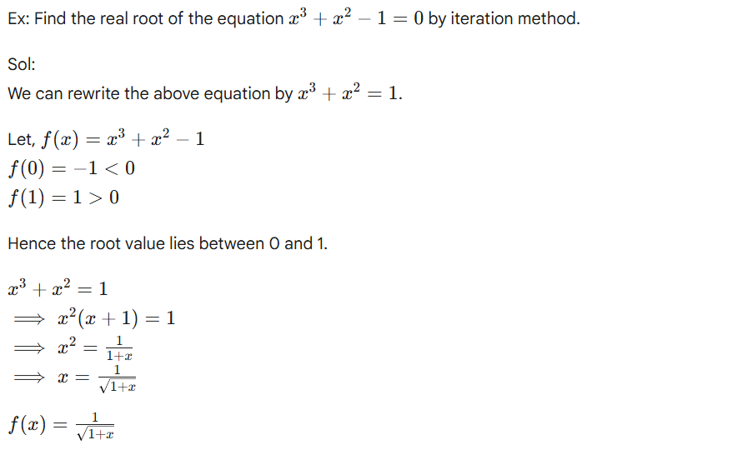

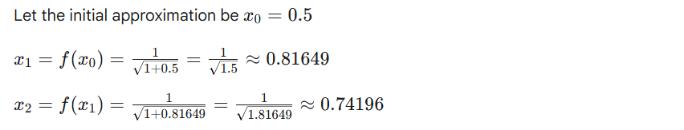

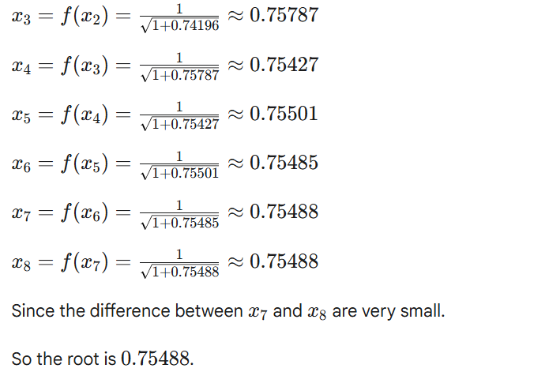

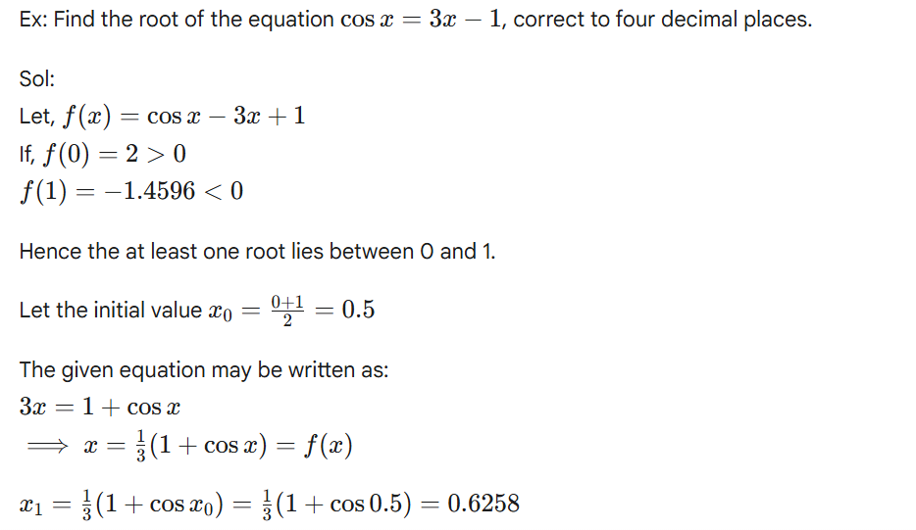

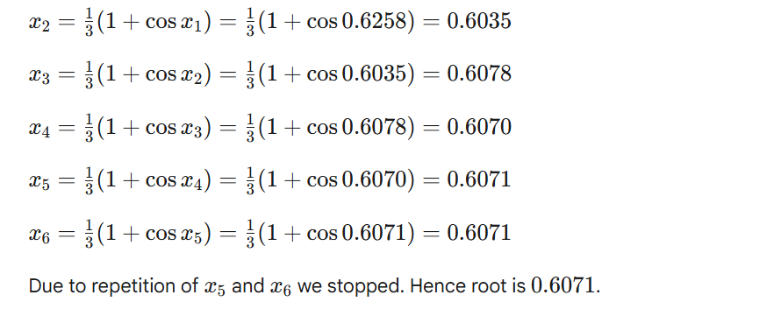

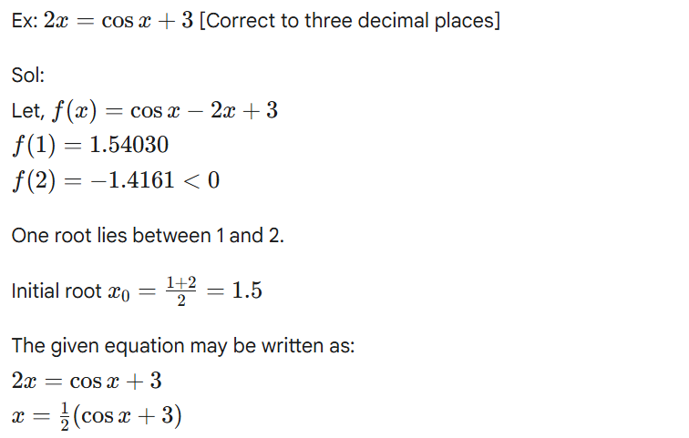

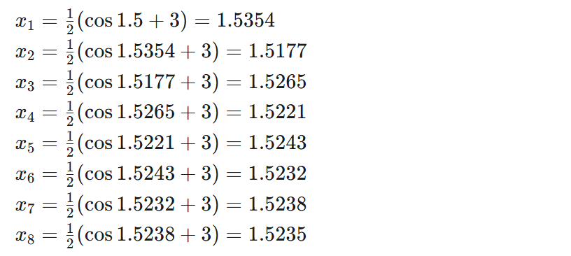

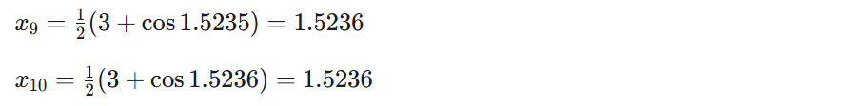

Due to repetition of x9​ and x10​, we stop calculation. Hence, the root is 1.523 correct to three decimal places.

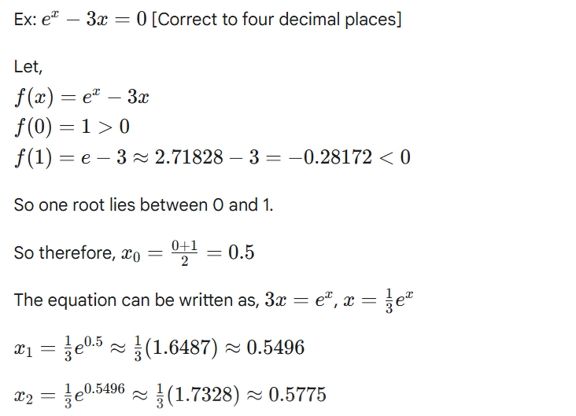

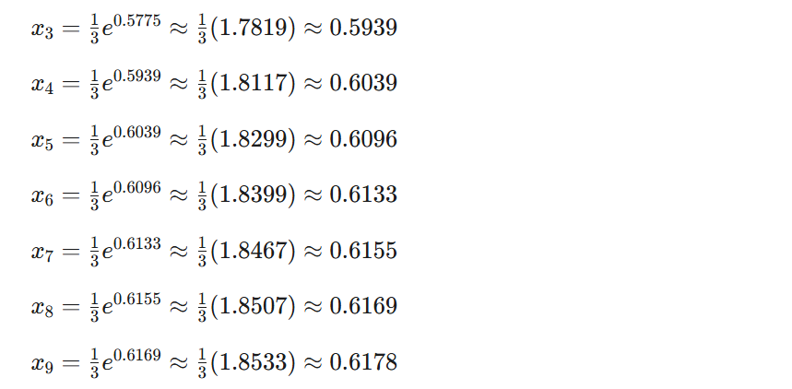

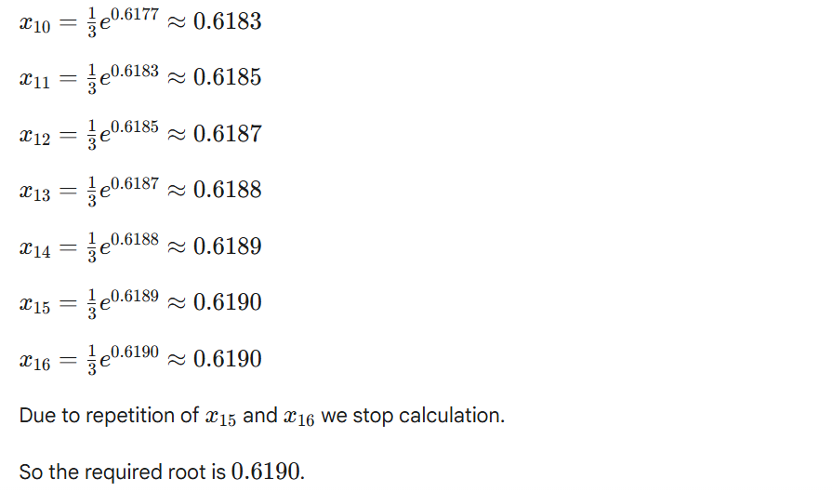

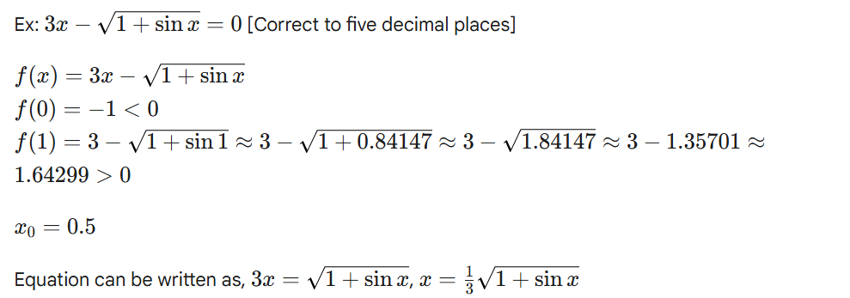

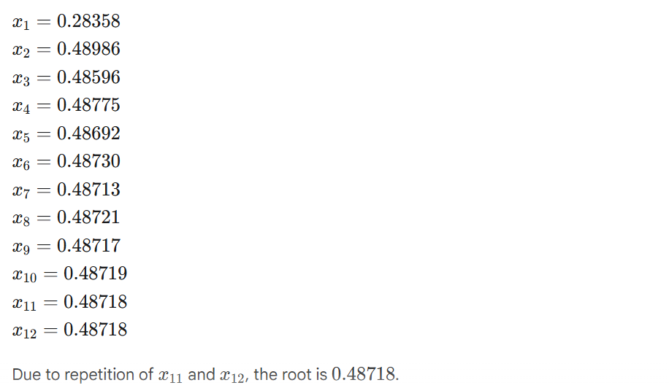

Ex: cosx−xex=0

Let f(x)=cosx−xex

f(0)=1>0

f(1)=−2.1779<0

So one root lies between 0 and 1.

Let x0​=0.5

Equation can be written as x = cos(x)​/ex

x1​=0.5323

x2​=0.5060

x3​=0.5273

x4​=0.5100

x5​=0.5241

x6​=0.5126

x7​=0.5219

x8​=0.5144

x9​=0.5205

x10​=0.5155

x11​=0.5195

x12​=0.5162

x13​=0.5189

x14​=0.5168

x15​=0.5186

x16​=0.5171

x17​=0.5183

x18​=0.5173

x19​=0.5181

x20​=0.5175

x21​=0.5179

x22​=0.5176

x23​=0.5179

x24​=0.5176

x25​=0.5178

x26​=0.5176

x27​=0.5178

x28​=0.5177

x29​=0.5178

x30​=0.5177

x31​=0.5177

So root is 0.5177.